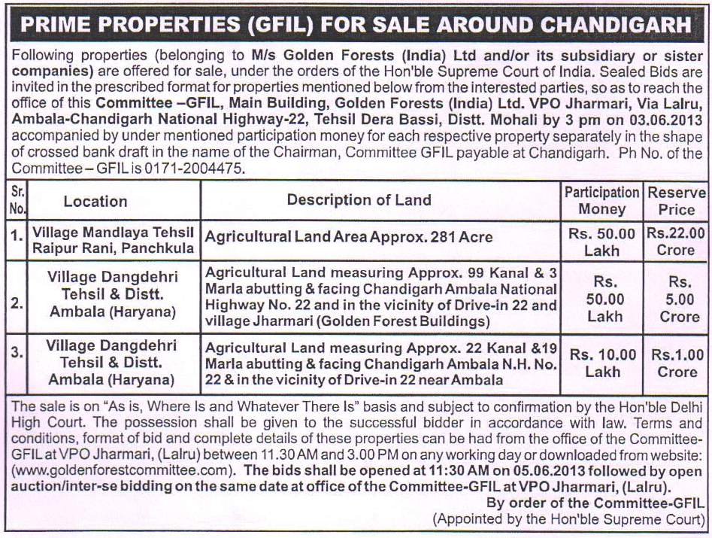
To be published on 13.05.2013.
TERMS AND CONDITIONS FOR SALE OF PROPERTIES
(ADVERTISEMENT DATED 13.05.2013)

1. The sealed bids are to be submitted separately for each property along with the participation money payable by way of crossed pay order or crossed bank draft in favour of “The Chairman, Committee-GFIL”, payable at Chandigarh. Bid(s) without participation money shall be rejected.
2. Sealed bid may be submitted, by a person either individually or jointly with others, on a plain paper in the format given below. If submitted jointly, then each of the joint bidders must sign the bid. Also the names/addresses of all joint bidders should be stated in capital letter legibly.
3. In case the bidder is a Company, the bid must be accompanied by a Resolution of the Company, along with the Corporate seal.
4. Each and every bidder shall attach with his/its bid form a self-attested copy of his/its PAN Card and shall make requisite payment from his/its own bank account.
5. The sealed Bids may be submitted on or before as per the date stipulated for this purpose in the relevant advertisement in the newspapers upto 3 pm at the Office of the Committee-GFIL, Main Building, Golden Forests (India) Limited, Village & Post Office Jharmari, Ambala-Chandigarh National Highway-22, Tehsil Dera Bassi, District Mohali(Punjab).
6. Before submitting sealed bid, the Intending purchasers are advised to inspect the all government records including Municipal/Revenue records of the property. They are also advised to physically inspect the property concerned before offering bid for it.
7. Terms and conditions of sale may be amended, modified or altered by the Committee at any time without notice and without assigning any reason.
8. Committee reserves the right and power to reject any or all the bids, wholly or partially or withdraw any property(ies) from sale, without assigning any reason whatsoever.
-2-
9. Further the property may be put to “Open Bidding” among participating
bidders and others.
10. Within ten days of being declared as successful bidder, he/it shall further deposit 20% (excluding participation money) with the Committee-GFIL in the shape of crossed payee account bank draft payable at Chandigarh, in favour of the Chairman, Committee – GFIL, Chandigarh.
11. In case the highest bidder fails to deposit aforesaid amount of 20% within the prescribed period, his participation amount shall stand forfeited.
12. No bidder shall be allowed to withdraw his/its bid after the closing date and time of the receipt of bids.
13. On deposit of 20% of the bid money as required in condition No.10 supra, the Committee shall make a recommendation to the Hon’ble Delhi High Court for confirmation of sale in favour of the highest bidder.
14. The entire balance amount of the highest bid (exclusive of the participation money and 20% of the bid amount already deposited) shall be deposited by the successful bidder with the Committee within thirty days of the date of confirmation of the sale by Hon’ble Delhi High Court.
15. If the highest bidder fails to deposit the balance of sale price within the prescribed period as indicated above, his participation amount and 20% of
the bid money already deposited by him shall stand forfeited and the property shall be re-advertised for sale.

16. Unsuccessful bidder will be refunded the participation money without interest within one week from the date of fall of hammer in the name of the successful bidder.
17. The sale of properties is on “As is, Where Is and Whatever There Is” basis and subject to the acceptance of the bid by the Committee and its subsequent confirmation by the Hon'ble High Court of Delhi.
18. Court Sale Certificate shall be issued and registered in the name of the successful bidder in whose name the sale has been confirmed by the Hon’ble High Court of Delhi.
-3-
19. The possession of property shall be given only after the receipt of full and final sale consideration from the successful bidder (in whose favour the sale is confirmed by the Hon'ble High Court of Delhi) and the sale certificate has been issued and duly registered. In case of undivided share, its symbolic possession, in accordance with law, shall be given.
20. The liability of any tax or duty or charges, incidental to sale, or due on the property shall be borne by the purchaser.
21. It shall be the responsibility of the purchaser to procure/obtain the licence, change of land-user and permissions from the government/ municipality/ administration using for residential purposes or establishing any industry/business/trade etc. in the premises purchased.
22. The particulars and description of properties given in the advertisement have been stated to the best of the information of the Committee and the Committee shall not be responsible for any error, misprint or omission in the sale notice or in the description of the property(ies).
23. When the inter se/open bidding is in progress, nobody shall be allowed to leave the venue of the bidding.
24. Conditional bids will not be accepted.
25. The prospective bidder shall file an affidavit in the prescribed format affirming that he has checked the government’s revenue and municipal record pertaining to the land / property and has inspected the advertised land/property physically also. He will state in the affidavit that he is satisfied with correctness of the details of the advertised land/property and also about the legal title of the Golden Forest (India) Limited in it. He will further state that after being declared successful bidder by the Committee

-4-
or after the confirmation of sale by the Hon’ble Court, he will not be entitled to file any objection on any of these grounds.
Terms & Conditions Approved.

Sd/- Sd/- Sd/-
R.N.Aggarwal H.L.Randev B.S.Bedi
Chairman Member Member
-5-

Format of Bid
1. Name and Address of bidder(s).

2. PAN Number(s) of all the Joint bidders:
Sr.No. Name and address PAN Number
1.

2.

3.

4.

(Self attested photo copies of PAN Cards should be enclosed)
3. Details / S. No. of property for which bid is being submitted.

4. Amount of bid or bid value(in words and figures).

5. Details of participation money i.e. demand draft no., amount, dated of issue,
name of the bank etc.

6. Declaration: I /We declare that I have read and understood the Terms and
Conditions of the sale of the properties prescribed by the Committee – GFIL
and I /we shall abide by the same. I/We further declare that my/our bid is not
conditional. I/We have also filed the affidavit forming part the bid.

7. Signature and seal (if any) of the bidder (All bidders are required to sign).

8. Date.
-6-

Affidavit

I, _________, S/o _____________, R/o___________________ solemnly declare and affirm that:

1. That I/We have read and understood the Terms and Conditions of the sale of the properties prescribed by the Committee-GFIL and I /we shall abide by the same.
2. That I/We further declare that my/our bid is not conditional.
3. That I/We have checked the government’s revenue record and municipal record pertaining to the advertised land/property and I/We are satisfied with correctness of the details provided to us by the Committee for which I/We have filed a bid.
4. That I/We have physically inspected the advertised land/property and found it free from encroachment.
5. That I/We declare that after being declared successful bidder by the Committee or after the confirmation of sale by the Hon’ble Court, I/We will not be entitled to file any objection before the Committee or before the Hon’ble Court, on the said grounds.

DEPONENT
Verification
I solemnly declare and affirm that the contents of my above affidavit are true and correct to my knowledge and belief and that nothing material has been suppressed or concealed therefrom.
Verified at Chandigarh on this the _______ day of ________, 2013.

DEPONENT

